PRACTICAL NO . 12:
Aim: Using Sysinternals tools for Network Tracking and Process Monitoring :
- Check Sysinternals tools
- Monitor Live Processes
- Capture RAM
- Capture TCP/UDP packets
- Monitor Hard Disk
- Monitor Virtual Memory
- Monitor Cache Memory
✓ Check Sysinternals tools : Windows Sysinternals tools are utilities to manage, diagnose, troubleshoot, and monitor a Microsoft Windows environment.
The following are the categories of Sysinternals Tools:
- File and Disk Utilities
- Networking Utilities
- Process Utilities
- Security Utilities
- System Information Utilities
- Miscellaneous Utilities
Monitor Live Processes : (Tool: ProcMon)
To Do: 1. Filter (Process Name or PID or Architecture, etc)
2. Process Tree
3. Process Activity Summary
4. Count Occurrence
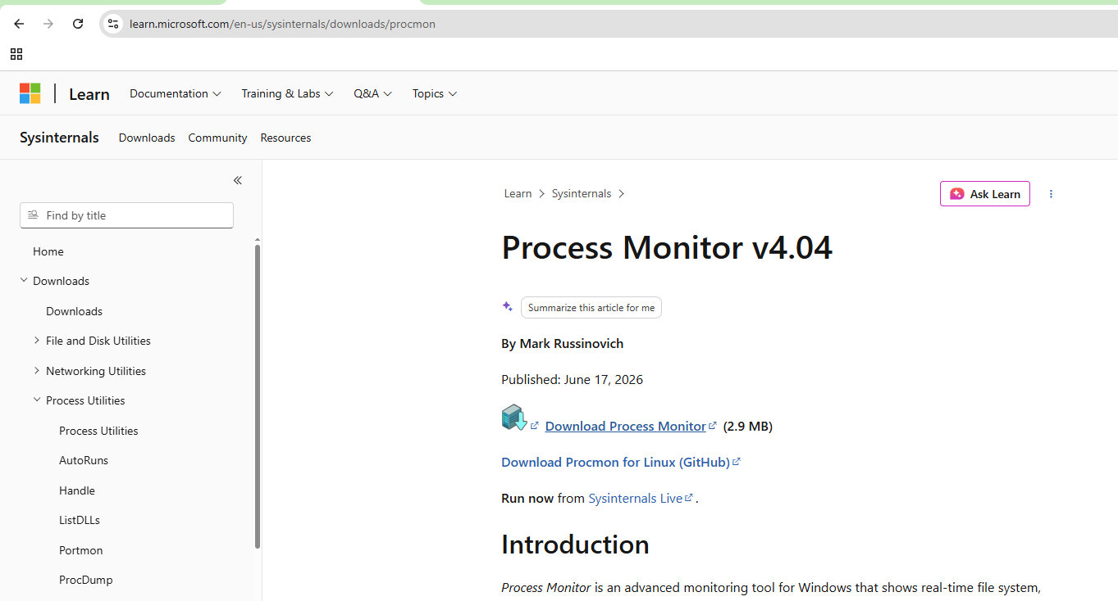
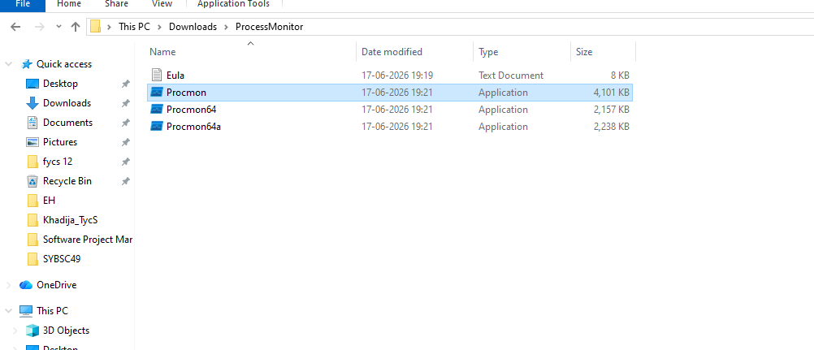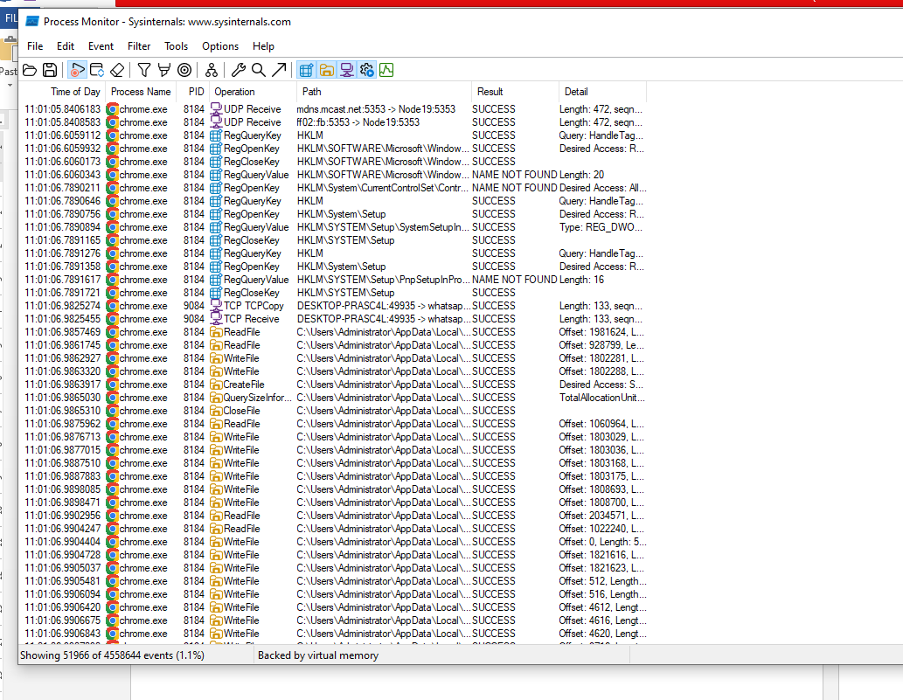

Filter Open ProcMon → Tools → Process Tree to view process hierarchy
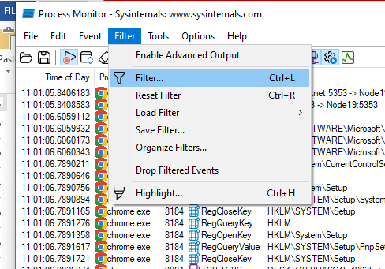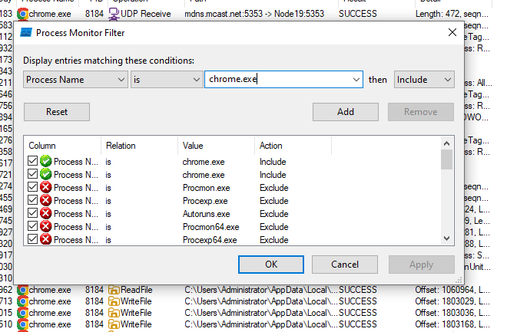

Tools -> process tree
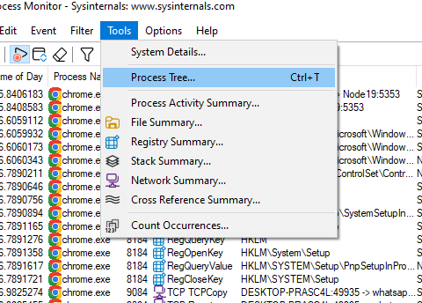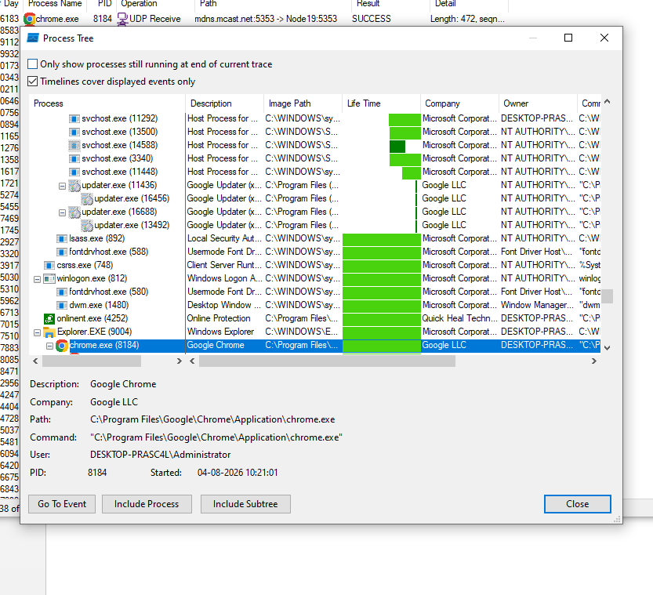

Event -> count occurance

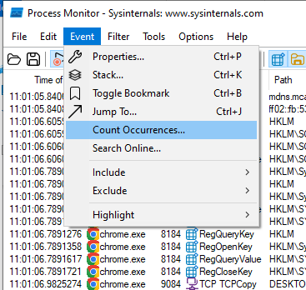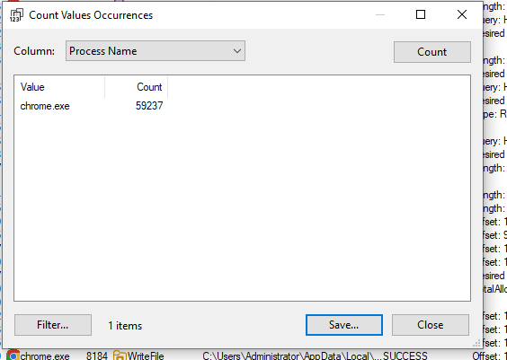

Tools -> File summary
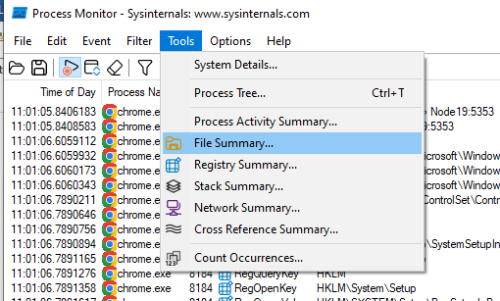
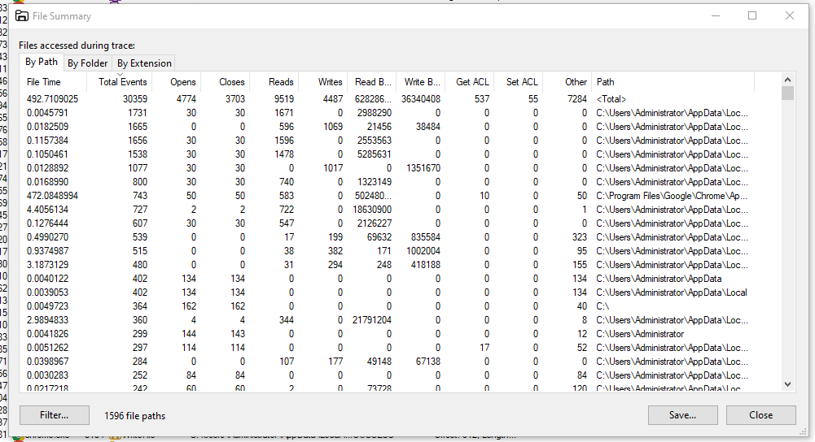

Capture RAM - Belkasoft Live RAM Capturer
Capture RAM (Tool: RAMCapture)
To Do: 1. Click Capture
2. Creates a .mem file of the system memory (RAM) utilized

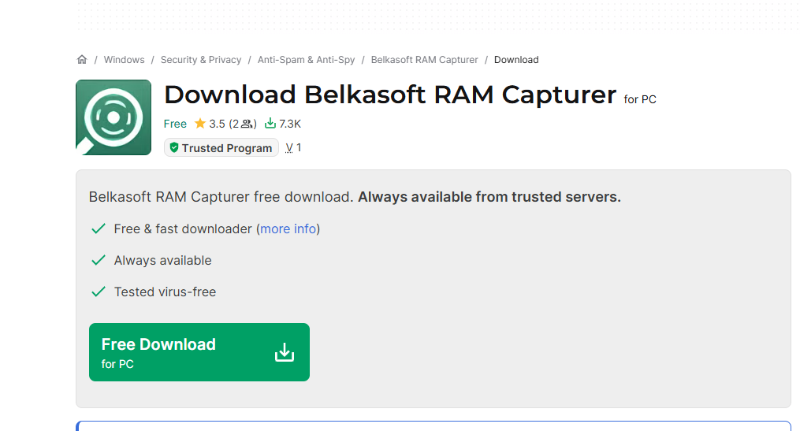

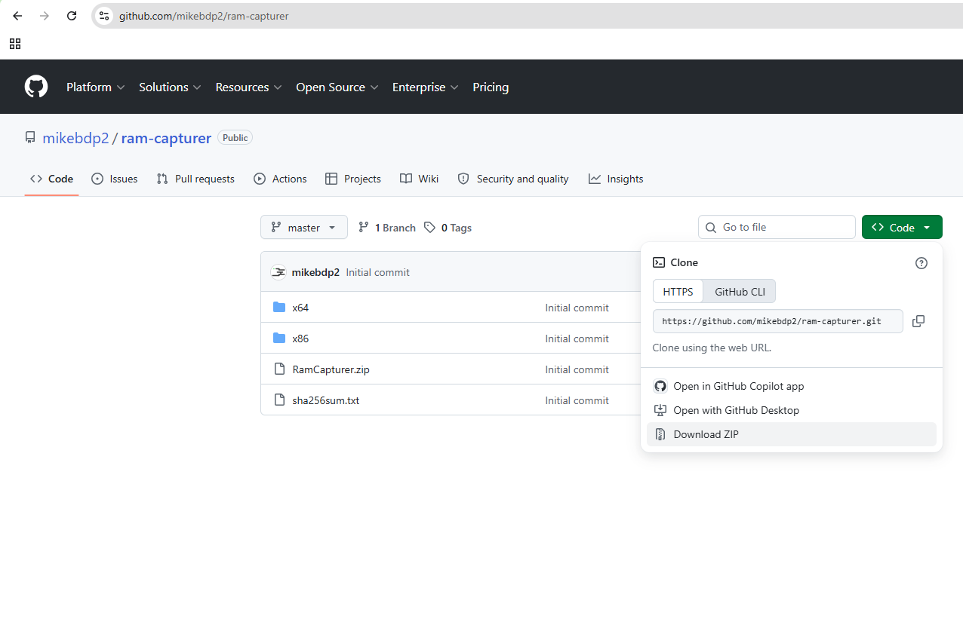
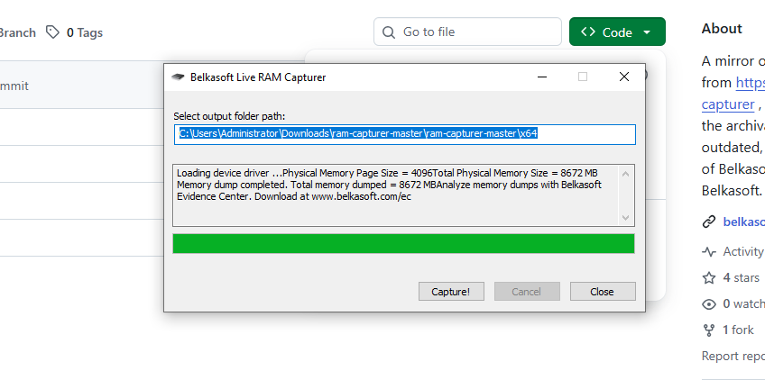
Capture TCP/UDP packets (Tool: TcpView) :
To Do:
1. Save to .txt file.
2. Whois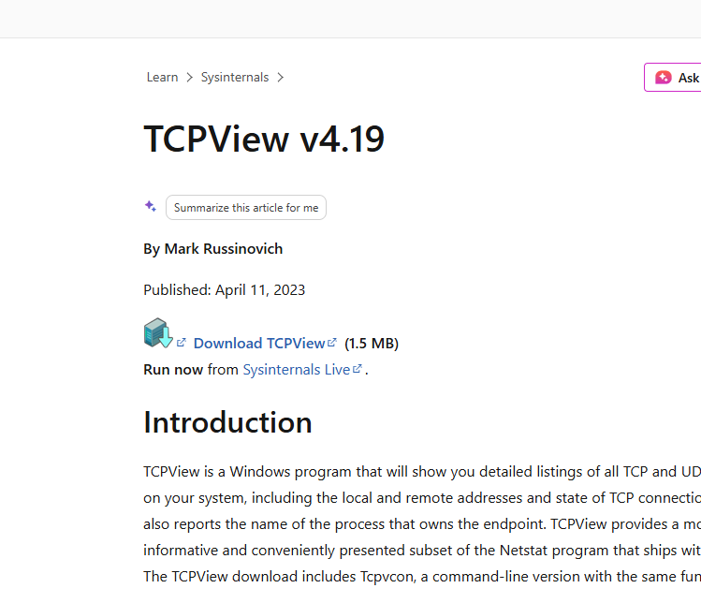
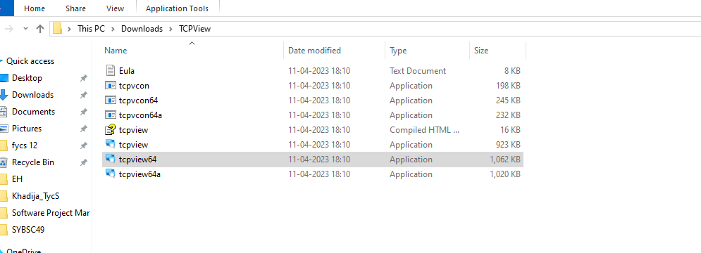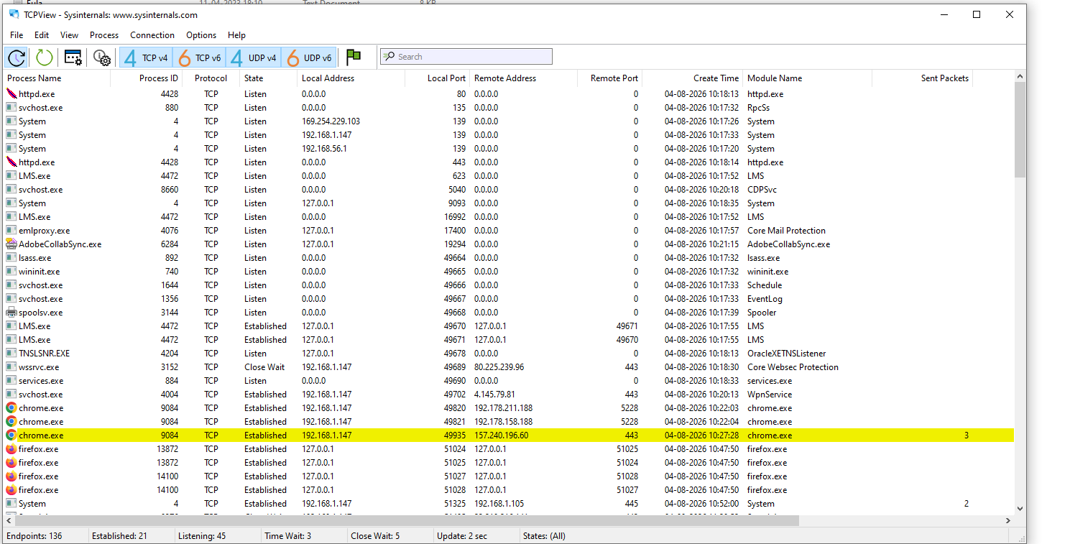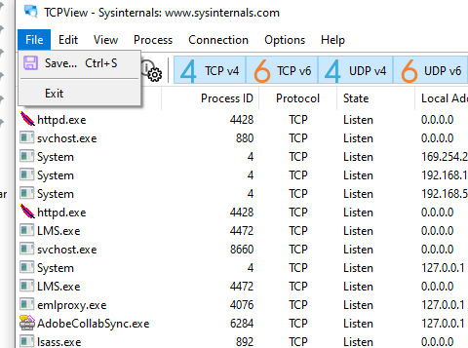

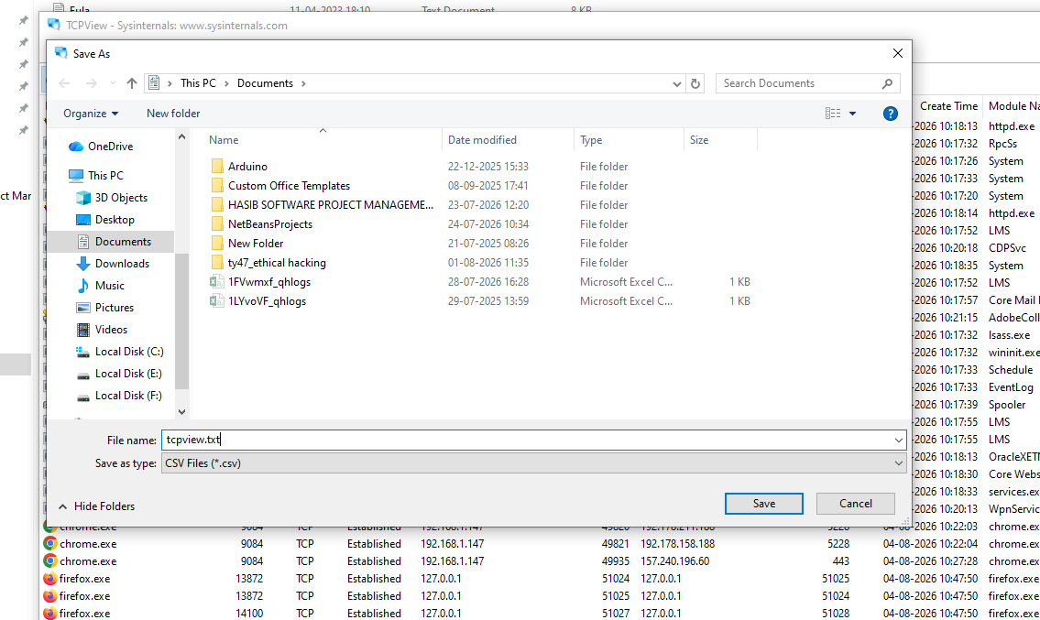

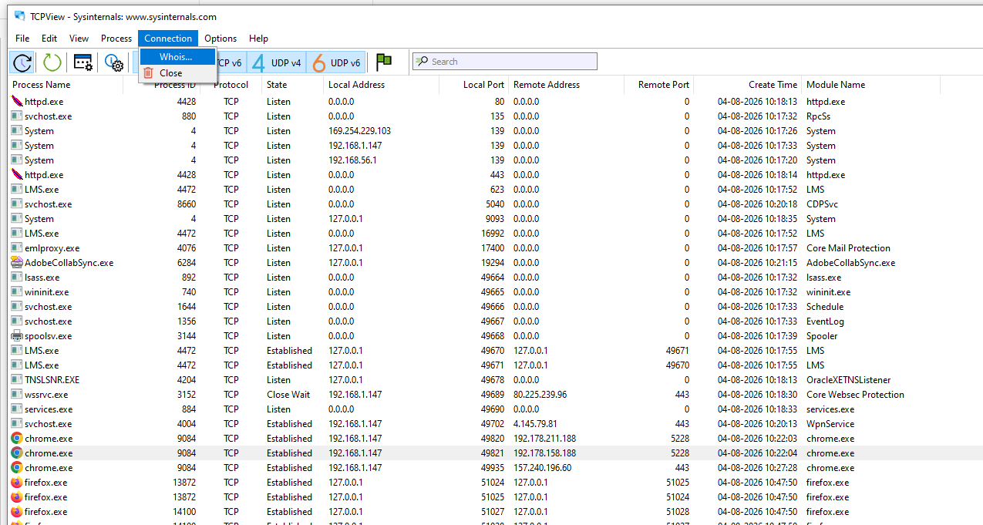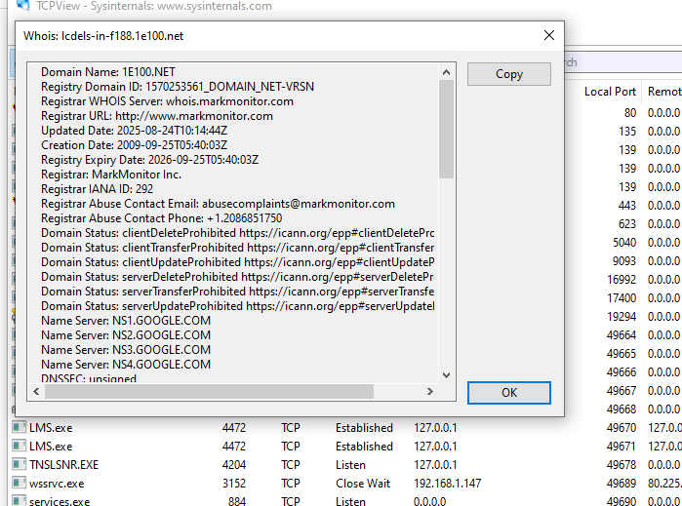

Monitor Hard Disk (Tool: DiskMon) :
To Do:
1. Save to .log file.
2. Check operations performed in the disk as per time and sectors affected. 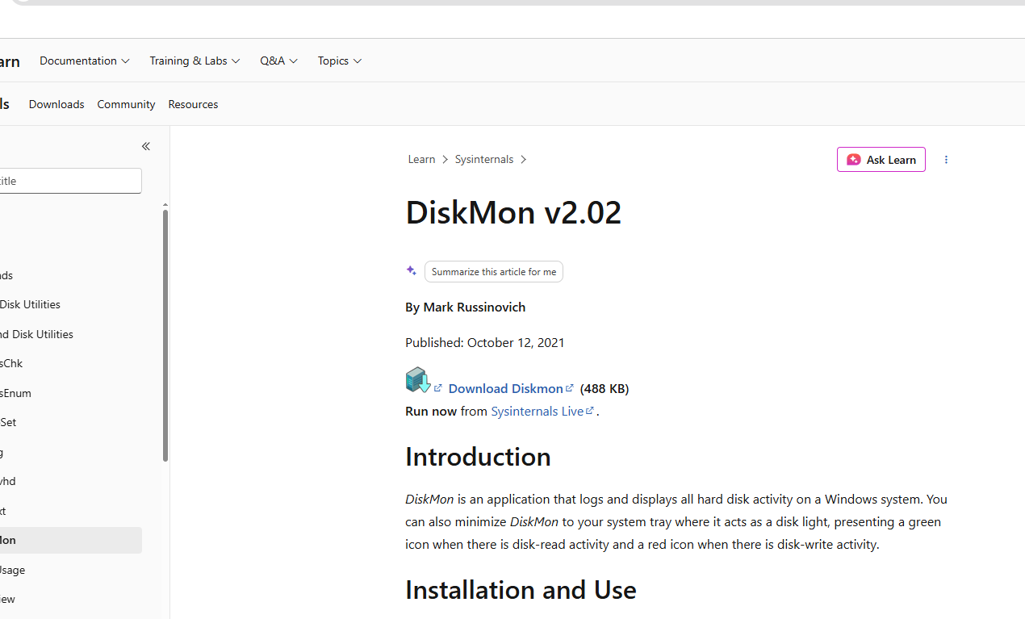

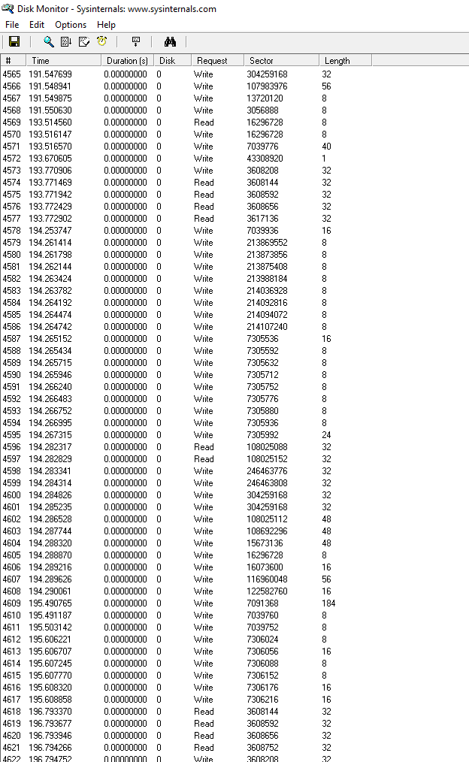
Download vmmap
Monitor Virtual Memory – VMMap
¬ Monitor Virtual Memory ( Tool : VMMAP) :
1.To Do: 1. Options – Show Free & Unusable Regions
2. File-> Select Process e.g. chrome.exe
3. Save to .mmp file.
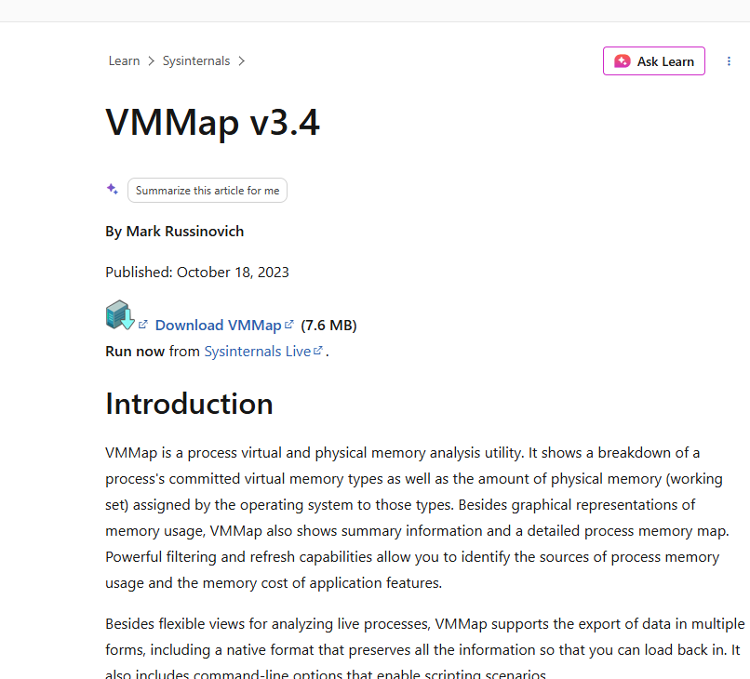
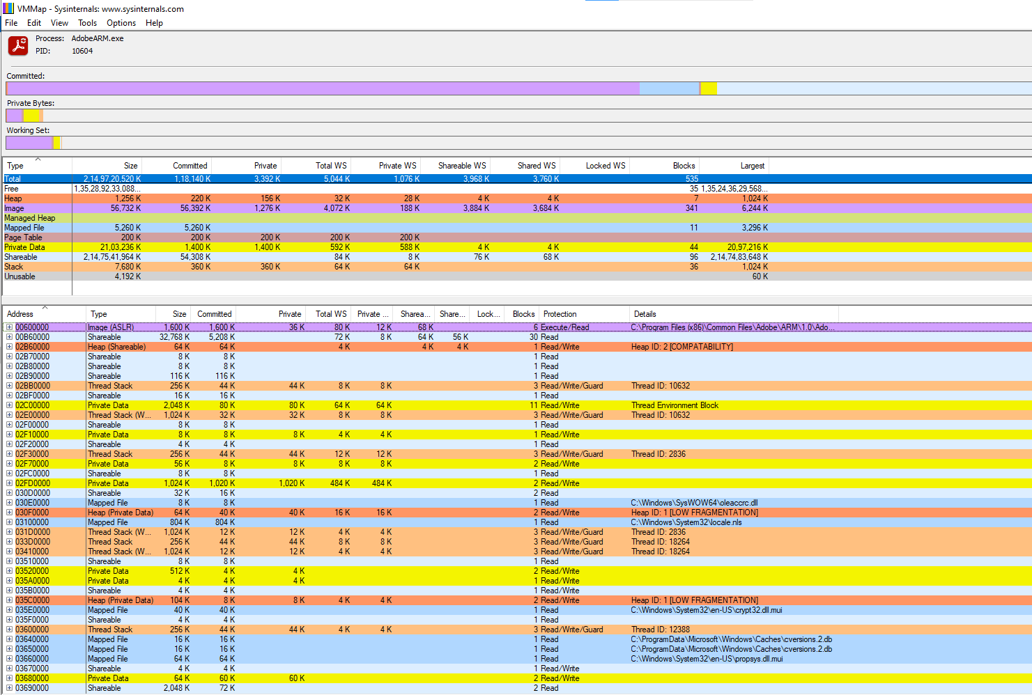
File -> select process
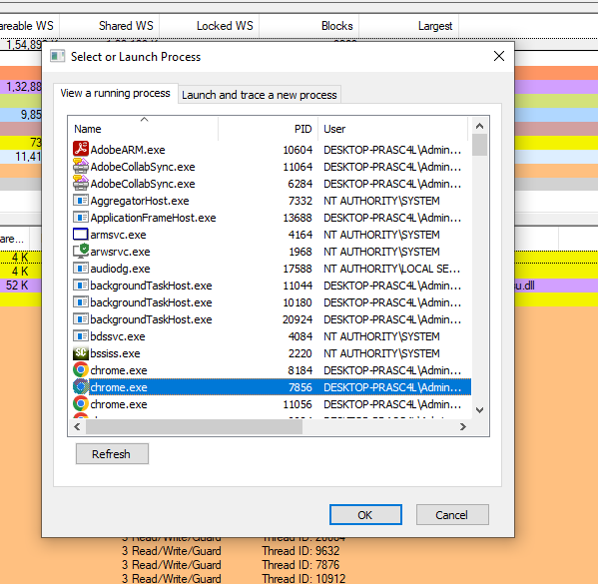
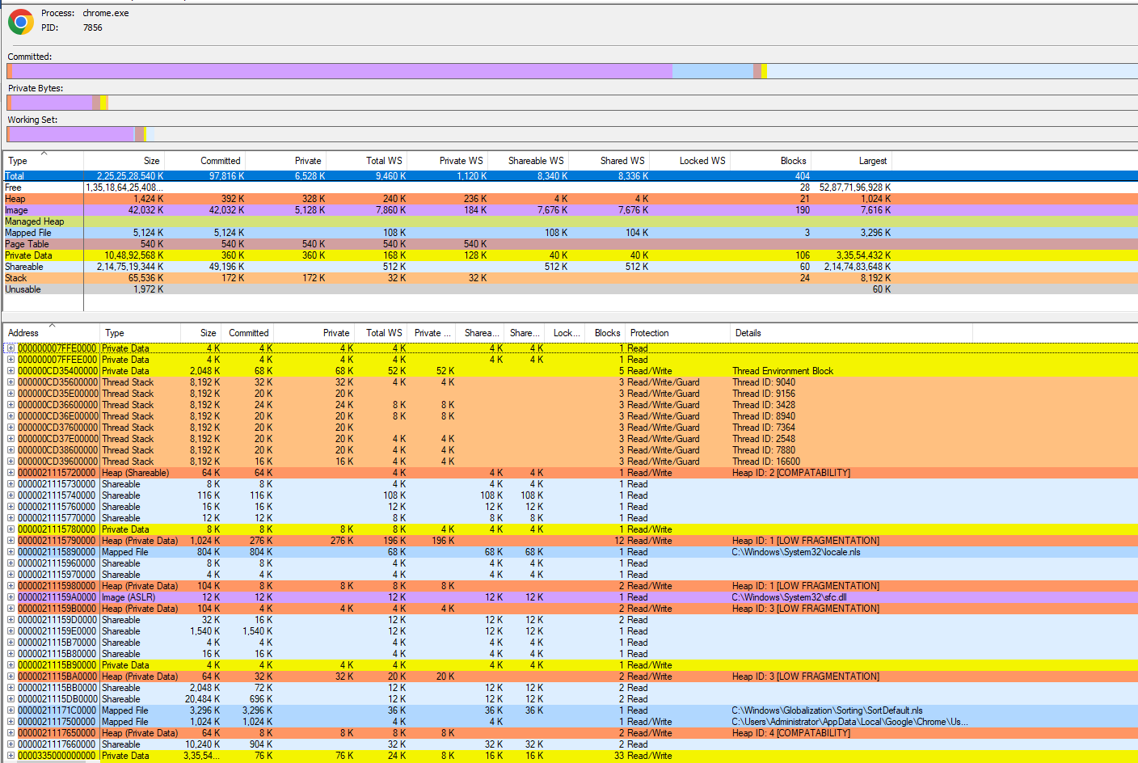
Download rammap

Monitor Cache Memory (Tool: RAMMap)
TO DO :
1.Save to .RMP file.